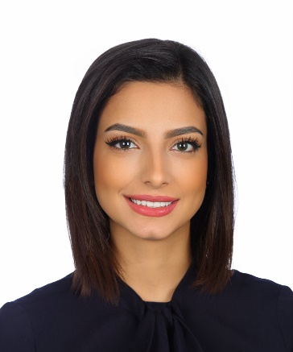
Dua’ Adel Abu Eker
Contact No: +962 79 9147799
Email: Doaa.adel234@gmail.com
Date of birth: Mar 1993

Career objective
A highly motivated and hardworking professional with extensive 7 years of experience in banking and finance sector. Looking for a challenging role with an organization to utilize knowledge, experience and competencies to contribute in the mission of achieving goals needed for the organization vision.

Professional experience

- Global Senior Operation treasury coordinator (Jun 2022 to Present).
Arab bank - Amman, Jordan
- Preparing daily, monthly, yearly reports for related department.
- Processing all types of Treasury Back Office transactions, including (FX, MM , CM)
- Uploading and verifying rates
- Managing subscriptions for wealth management.

- Treasury back office Officer (Feb 2021 to Jun 2022).
Housing Bank for Trade and Finance - Amman, Jordan
- Making changes if feasible and testing the systems
- Issuing and verifying all types of Treasury Back Office messages such as (MT3XX, MT5XX, MT202, MT210, MT999…)
- Follow up with all certificates of deposits
- Prepare monthly reports for financial department for local bonds.
- Auditing all international transactions.
- Receiving all invoices for clients buying and selling stocks and compare it with other systems.
- Checking balances with other institutions.

- Payment hub Officer - (Sep 2020 to Feb 2021).
Housing Bank for Trade and Finance - Amman, Jordan
- Issuing outward transfers on bank system after receiving transfer submission from branches.
- Creating or verifying all types of messages on swift system.
- Follow up with other banks if needed.
- Distribute all types of messages received to the other units and departments.
- Sanction observation to all messages received or sent by our institution.
- Follow up the messages with the compliance department if any sanction flag appeared on FIRCO system.
- Adding specious names to FRICO system

- VIP customer service - (April 2020 to Sep 2020).
Housing Bank for Trade and Finance - Amman, Jordan
- Analyze customer requirements and develop appropriate banking products.
- Support relationship managers in delivering efficient and quality service to customers.
- Serve customers by providing product and services information and resolving product and service problems.
- Opens customers’ accounts (saving, current and salaries accounts).
- Providing high-level customer service.

- Teller - (April 2020 to Sep 2020).
Housing Bank for Trade and Finance - Amman, Jordan
- Count currency, coins, and checks received, by hand or using currency-counting machine, in order to prepare them for deposit or shipment to branch banks or the Federal Reserve Bank.
- Receive checks and cash for deposit, verify amounts, and check accuracy of deposit slips.
- Cash checks and pay out money after verifying that signatures are correct, that written and numerical amounts agree, and that accounts have sufficient funds.
- Balance currency, coin, and checks in cash drawers at ends of shifts, and calculate daily transactions using computers, calculators, or adding machines.
- Following bank procedures when performing transactions.

Main projects:

- ISO20022
- Rate automation
- Certificate of deposit interest automation
- MT199-MT202 automation
- Core banking enhancements
- Quantum system upgrade (treasury system)

Education
- Omareyah private school
- Applied Science University(2011-2015)
Bachelor of Science in Business Administration 82.4% (very good)

Personality traits
- Excellent logical, analytical and computational skills.
- Excellent communication skill both orally and in writing.
- Strong motivational skills.
- Ability to work under pressure.
- Ability to work individual as well as in team
- Continues self-development and adjustable to work with newly acquired knowledge
Languages
- Arabic Native.
- English Good Reading and Writing

References
Upon request

